How to Enter SMART Goals in Naviance

1. Log in to Naviance
- Username= first initial and last name ex. Ida Indian= iindian
- Password= if you don’t remember your password, see your counselor to reset it.
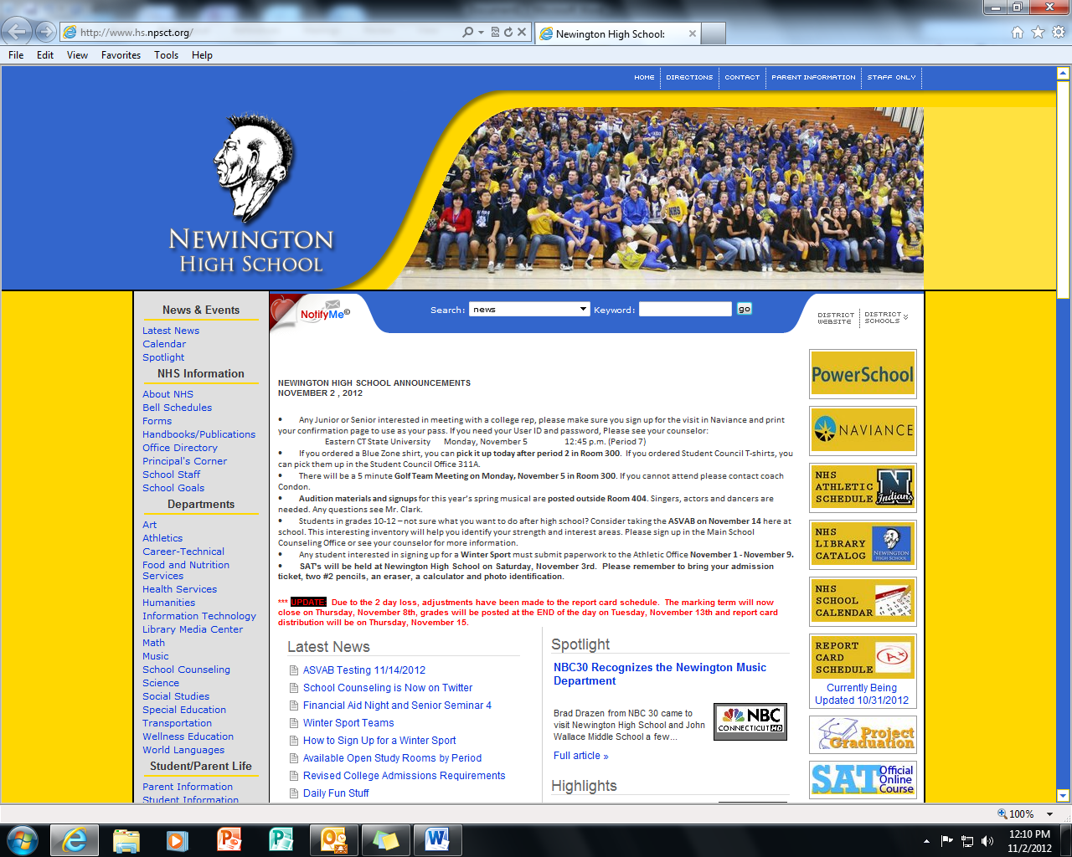

2. Go to Planner Tab
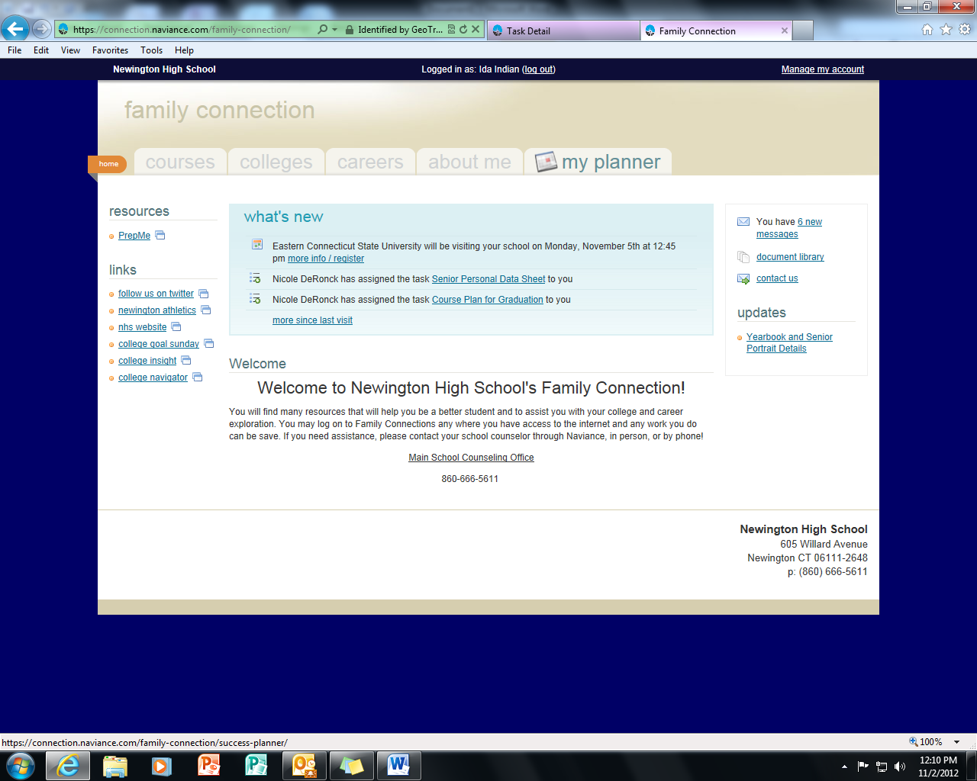

3. Click on Tasks Assigned to Me (Purple Tab)

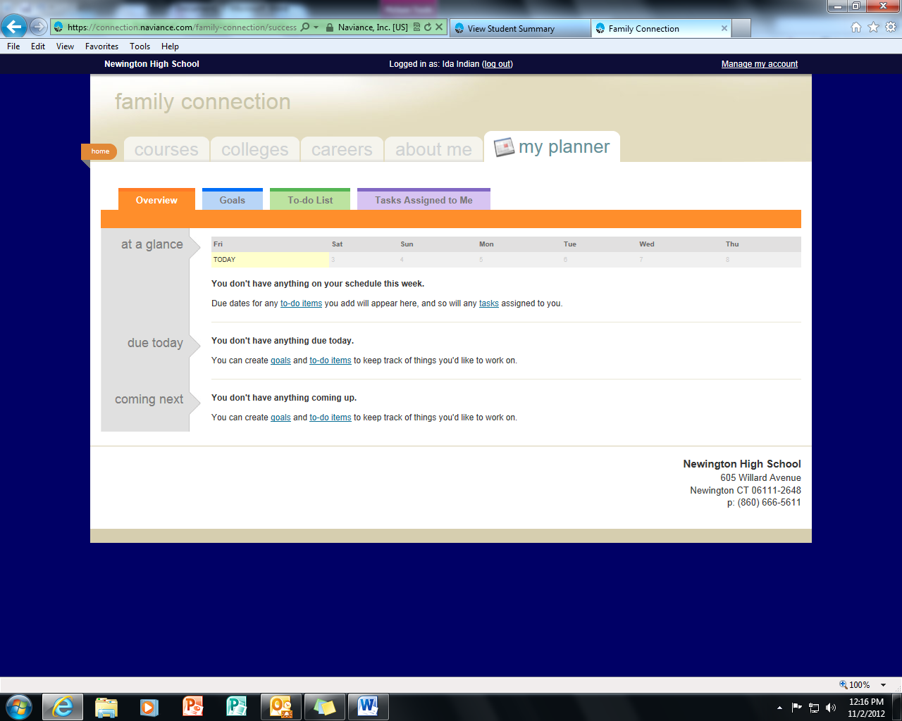

4. Click on SMART Goal

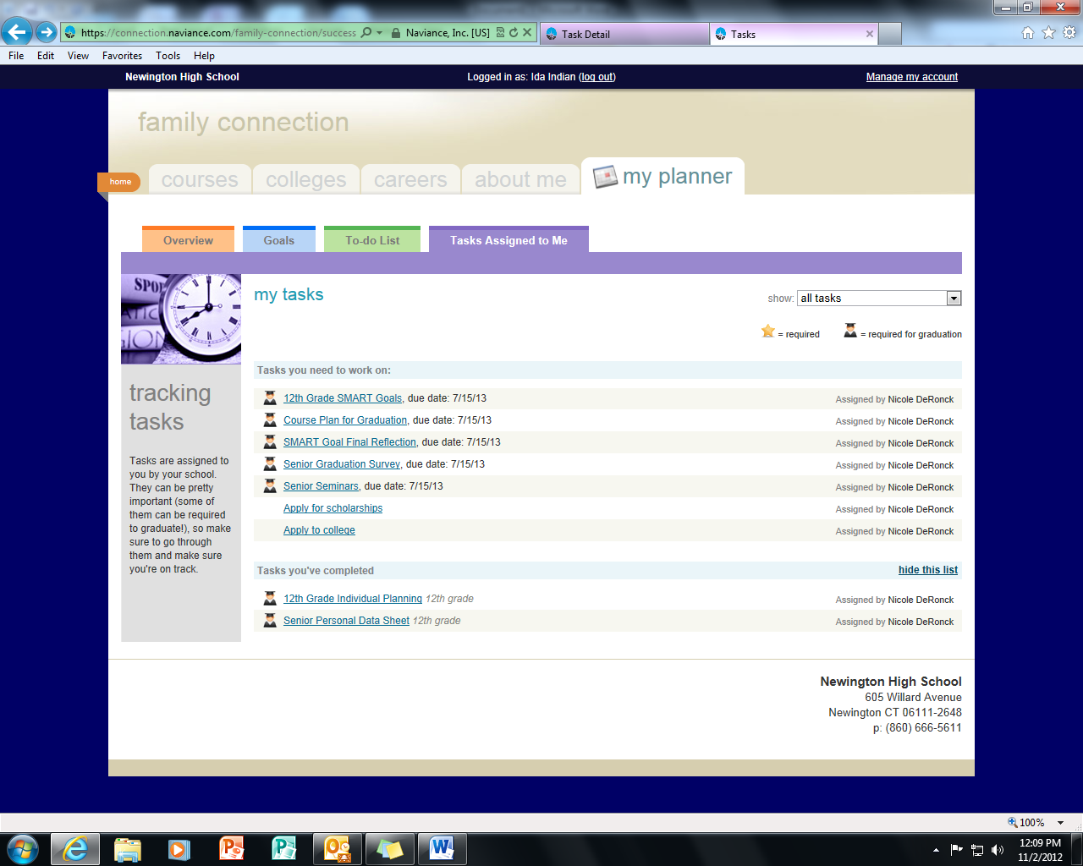
5. Click on Complete a Survey
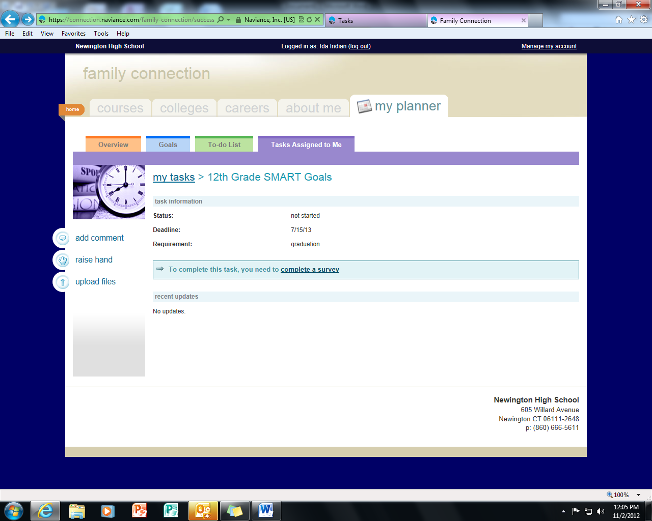

4. Complete your goal and save your work
