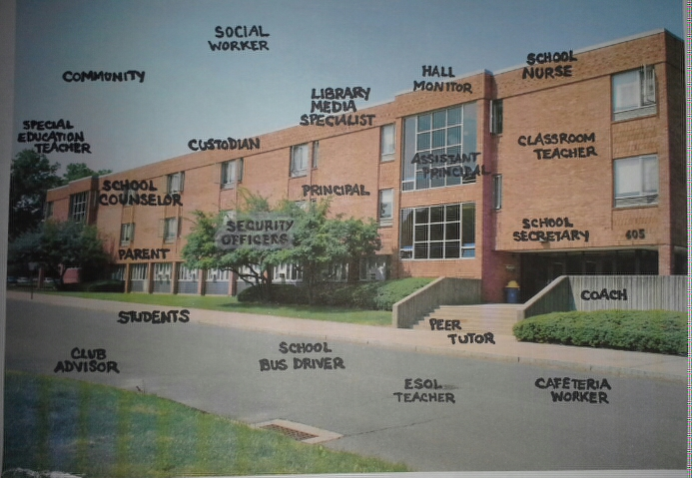

Cut the picture into randomly shaped pieces. There should be one word (one type of identity) in each piece. Place the pieces in envelopes. The directions, under “Pieces of the Puzzle”, have sheets that describe what pieces go into each envelope.

